Lagged cross-correlation: EURUSD and GBPUSD
Method 12 / daily log returns / K_max=10 / Alpari D1 full available history

Study setup
Logical pair: EURUSD , GBPUSD
Broker symbols: EURUSD_i , GBPUSD_i
Snapshot: 2026-11-03_majors_alpari_D1
Timeframe: D1
Matched return window: 1999-01-05 to 2026-11-02 (UTC bar dates)
Matched return count n: 7202
Dropped unfinished last bar dated 2026-11-03 UTC after a tick-volume check against the prior complete day.
Lag definition: rho_X->Y(k) = Corr(x_t, y_{t+k}) on matched D1 bars
K_max = 10; headline lag k = 1 (both directions)
Complete matched rows (Excel): EURUSD-GBPUSD_Lagged_D1.xlsx
Complete matched rows (HTML table): EURUSD-GBPUSD_Lagged_D1_data.html

Method carried forward
Lagged cross-correlation measures Pearson correlation between matched daily log returns of close, ln(close_t / close_t-1), after shifting one series forward by k bars on the matched panel. Quotes are not inverted. rho_{X->Y}(k) = Corr(x_t, y_{t+k}) with n_k = n - k. K_max = 10 is fixed before estimation. The headline is the pre-specified lag k = 1 in both directions. k = 0 is the same-bar side check. The lag inside 1..10 with the largest absolute rho is stored as a descriptive column only; it is not a selected result. This is a linear screen, not proof of forecast edge, economic cause, or a trading signal.

Results (headline k=1)
rho_EURUSD->GBPUSD(1): 0.002079 (n=7201)
95% Fisher interval EURUSD->GBPUSD: [-0.021019, 0.025176]
rho_GBPUSD->EURUSD(1): -0.019352 (n=7201)
95% Fisher interval GBPUSD->EURUSD: [-0.042431, 0.003747]
Same-bar rho(k=0): 0.641738
Largest |rho| among k=1..10 (descriptive only, not selected): EURUSD->GBPUSD k=8 rho=0.032281; GBPUSD->EURUSD k=10 rho=-0.025691

CCF table
k | rho_EURUSD_to_GBPUSD | n_EURUSD_to_GBPUSD | rho_GBPUSD_to_EURUSD | n_GBPUSD_to_EURUSD
0 | 0.64173802 | 7202 | 0.64173802 | 7202
1 | 0.00207934 | 7201 | -0.01935199 | 7201
2 | 0.01786882 | 7200 | -0.00233813 | 7200
3 | -0.00442958 | 7199 | 0.00525632 | 7199
4 | 0.00808723 | 7198 | -0.00678741 | 7198
5 | -0.0041932 | 7197 | 0.00789864 | 7197
6 | 0.00294189 | 7196 | -0.02468942 | 7196
7 | 0.00029383 | 7195 | -0.00564409 | 7195
8 | 0.03228131 | 7194 | -0.00149877 | 7194
9 | 0.01046585 | 7193 | -0.02342994 | 7193
10 | -0.00629394 | 7192 | -0.02569088 | 7192

Conclusion
At the pre-specified lag k=1 for EURUSD and GBPUSD, rho_{EURUSD->GBPUSD}(1) = 0.0021 (n=7201) and rho_{GBPUSD->EURUSD}(1) = -0.0194 (n=7201). Same-bar rho(k=0) = 0.6417. Largest |rho| among k=1..10 is descriptive only: EURUSD->GBPUSD at k=8 (0.0323); GBPUSD->EURUSD at k=10 (-0.0257). This is a linear screen, not forecast proof or a trading signal.

Charts
Daily closes

Daily log returns

CCF both directions k=0..10
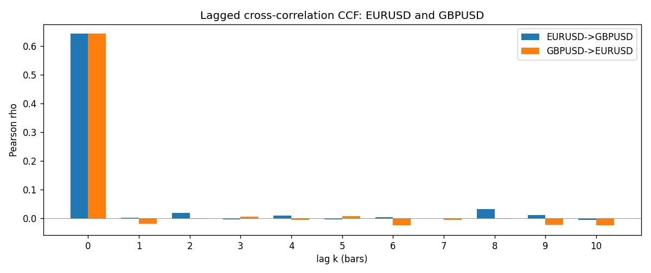

Data report
Every matched row is stored in the sibling Excel workbook named EURUSD-GBPUSD_Lagged_D1.xlsx (sheet matched_rows). The CCF sheet holds rho(k) for k=0..10. Embedding all rows as a Word table is impractical; the Word file holds column summaries and the first and last 15 rows.
Columns: time, EURUSD_open, GBPUSD_open, EURUSD_high, GBPUSD_high, EURUSD_low, GBPUSD_low, EURUSD_close, GBPUSD_close, EURUSD_tick_volume, GBPUSD_tick_volume, EURUSD_spread, GBPUSD_spread, EURUSD_real_volume, GBPUSD_real_volume, EURUSD_log_return, GBPUSD_log_return
Column summaries (matched calculation rows)
column | count | mean | std | min | 25% | 50% | 75% | max
EURUSD_open | 7202 | 1.1812936 | 0.15087968 | 0.8272 | 1.086065 | 1.166145 | 1.293925 | 1.5995
GBPUSD_open | 7202 | 1.5160822 | 0.2182507 | 1.06854 | 1.325005 | 1.51141 | 1.63166 | 2.1066
EURUSD_high | 7202 | 1.1864255 | 0.15147858 | 0.8326 | 1.0901775 | 1.17127 | 1.2992275 | 1.6038
GBPUSD_high | 7202 | 1.5223773 | 0.21881719 | 1.08366 | 1.329795 | 1.51815 | 1.63839 | 2.1161
EURUSD_low | 7202 | 1.1762813 | 0.15020267 | 0.8227 | 1.0819975 | 1.162535 | 1.288315 | 1.5865
GBPUSD_low | 7202 | 1.5097565 | 0.21747799 | 1.03518 | 1.3195075 | 1.503295 | 1.6243825 | 2.0983
EURUSD_close | 7202 | 1.1813323 | 0.15085599 | 0.8267 | 1.0860025 | 1.166105 | 1.2939475 | 1.5997
GBPUSD_close | 7202 | 1.5161468 | 0.21820921 | 1.06879 | 1.325125 | 1.511325 | 1.632095 | 2.1065
EURUSD_tick_volume | 7202 | 102990.53 | 173401.83 | 218 | 9388.25 | 52708 | 99433.75 | 1471626
GBPUSD_tick_volume | 7202 | 94813.509 | 153540.37 | 62 | 9988.5 | 52886.5 | 91789.25 | 1273370
EURUSD_spread | 7202 | 19.400444 | 16.577153 | 0 | 8 | 12 | 30 | 50
GBPUSD_spread | 7202 | 26.974313 | 19.194125 | 0 | 11 | 20 | 50 | 50
EURUSD_real_volume | 7202 | 4.0233049e+10 | 1.6674277e+11 | 0 | 0 | 0 | 0 | 3.6149665e+12
GBPUSD_real_volume | 7202 | 3.5555961e+09 | 8.4432361e+10 | 0 | 0 | 0 | 0 | 2.4038164e+12
EURUSD_log_return | 7202 | -7.71e-06 | 0.00580133 | -0.03123819 | -0.00324586 | 0 | 0.00325471 | 0.03433183
GBPUSD_log_return | 7202 | -2.587e-05 | 0.00564523 | -0.08388241 | -0.00313091 | 3.124e-05 | 0.00317757 | 0.03112653
First 15 matched rows (selected columns)
time | EURUSD_close | GBPUSD_close | EURUSD_log_return | GBPUSD_log_return
1999-01-05 | 1.1758 | 1.6547 | -0.0048360507 | -0.0028966287
1999-01-06 | 1.1623 | 1.6537 | -0.011547966 | -0.00060452184
1999-01-07 | 1.1712 | 1.6502 | 0.0076280636 | -0.002118709
1999-01-08 | 1.1585 | 1.6405 | -0.010902799 | -0.0058954193
1999-01-11 | 1.1503 | 1.6312 | -0.007103287 | -0.0056851331
1999-01-12 | 1.1555 | 1.6349 | 0.0045103728 | 0.0022657001
1999-01-13 | 1.1681 | 1.6499 | 0.010845346 | 0.0091330396
1999-01-14 | 1.1681 | 1.6531 | 0 | 0.0019376331
1999-01-15 | 1.1563 | 1.6502 | -0.010153245 | -0.0017558204
1999-01-18 | 1.1605 | 1.6522 | 0.0036256946 | 0.0012112405
1999-01-19 | 1.1603 | 1.6553 | -0.00017235436 | 0.0018745281
1999-01-20 | 1.1566 | 1.6472 | -0.0031939256 | -0.0049053846
1999-01-21 | 1.1601 | 1.6524 | 0.0030215416 | 0.0031518998
1999-01-22 | 1.1587 | 1.6565 | -0.0012075213 | 0.0024781662
1999-01-25 | 1.1552 | 1.6585 | -0.0030251979 | 0.0012066366
Last 15 matched rows (selected columns)
time | EURUSD_close | GBPUSD_close | EURUSD_log_return | GBPUSD_log_return
2026-10-13 | 1.11965 | 1.32534 | 0.0037402957 | 0.0036434319
2026-10-14 | 1.11545 | 1.31884 | -0.0037582255 | -0.0049164679
2026-10-15 | 1.12172 | 1.32757 | 0.0056053107 | 0.0065976411
2026-10-16 | 1.12371 | 1.33257 | 0.0017724895 | 0.0037592051
2026-10-19 | 1.12086 | 1.33024 | -0.0025394633 | -0.0017500314
2026-10-20 | 1.12354 | 1.3377 | 0.0023881672 | 0.0055923442
2026-10-21 | 1.12318 | 1.33937 | -0.00032046717 | 0.0012476328
2026-10-22 | 1.12139 | 1.33967 | -0.0015949606 | 0.00022396082
2026-10-23 | 1.11989 | 1.33684 | -0.001338521 | -0.0021146949
2026-10-26 | 1.11735 | 1.33359 | -0.0022706559 | -0.0024340661
2026-10-27 | 1.11272 | 1.33044 | -0.004152342 | -0.0023648393
2026-10-28 | 1.1152 | 1.33254 | 0.0022262927 | 0.0015771808
2026-10-29 | 1.11772 | 1.33733 | 0.0022571351 | 0.0035881935
2026-10-30 | 1.11644 | 1.33913 | -0.0011458446 | 0.0013450605
2026-11-02 | 1.11881 | 1.3406 | 0.002120569 | 0.0010971256

